==================================================

Running Genetic Algorithm...

==================================================

==================================================

=== GENETIC ALGORITHM OPTIMIZATION ===

==================================================

[Initialization]

- Population size: 30

- Generations: 20

- Crossover rate: 80%

- Mutation rate: 20%

- Search space: 16 features

- Target: Minimize MSE using CatBoost

[==================================================

=== OPTIMIZATION RESULTS ===

==================================================

▶ Best MSE achieved: 45383746.958268

▶ Time elapsed: 472.52 seconds

▶ Features selected: 16/16 (0.0% reduction)

▶ Selected features:

1. region

2. year

3. manufacturer

4. model

5. condition

6. cylinders

7. fuel

8. odometer

9. title_status

10. transmission

11. drive

12. type

13. paint_color

14. state

15. lat

16. long

▶ Convergence progress:

- Initial MSE: 48714362.4863

- Final MSE: 45383746.9583

- Improvement: 6.8%

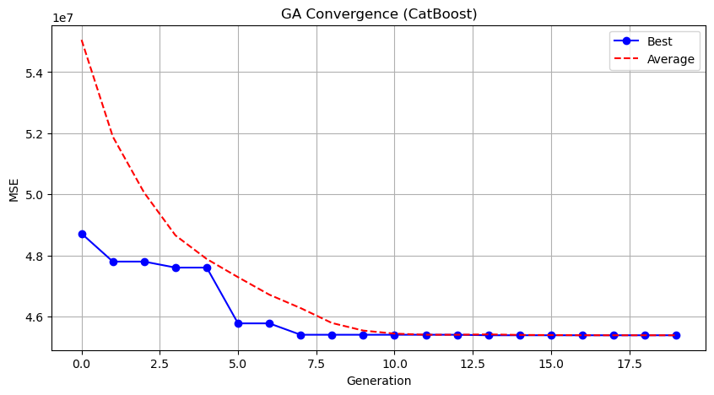

Genetic Algorithm completed successfully with MSE: 45383746.9583

==================================================

Running Particle Swarm Optimization...

==================================================

==================================================

=== PARTICLE SWARM OPTIMIZATION ===

==================================================

[Initialization]

- Swarm size: 30 particles

- Iterations: 20

- Cognitive weight: 0.5

- Social weight: 0.5

- Inertia weight: 0.5

- Search space: 16 features

- Target: Minimize MSE using CatBoost

==================================================

=== OPTIMIZATION RESULTS ===

==================================================

▶ Best MSE achieved: 45799023.628339

▶ Time elapsed: 495.05 seconds

▶ Features selected: 14/16 (12.5% reduction)

▶ Selected features (with weights):

1. region (weight: 0.995)

2. year (weight: 0.619)

3. manufacturer (weight: 0.700)

4. model (weight: 0.703)

5. condition (weight: 0.505)

6. cylinders (weight: 0.772)

7. fuel (weight: 0.860)

8. odometer (weight: 0.829)

9. title_status (weight: 0.933)

10. drive (weight: 0.671)

11. paint_color (weight: 0.710)

12. state (weight: 0.543)

13. lat (weight: 0.818)

14. long (weight: 1.000)

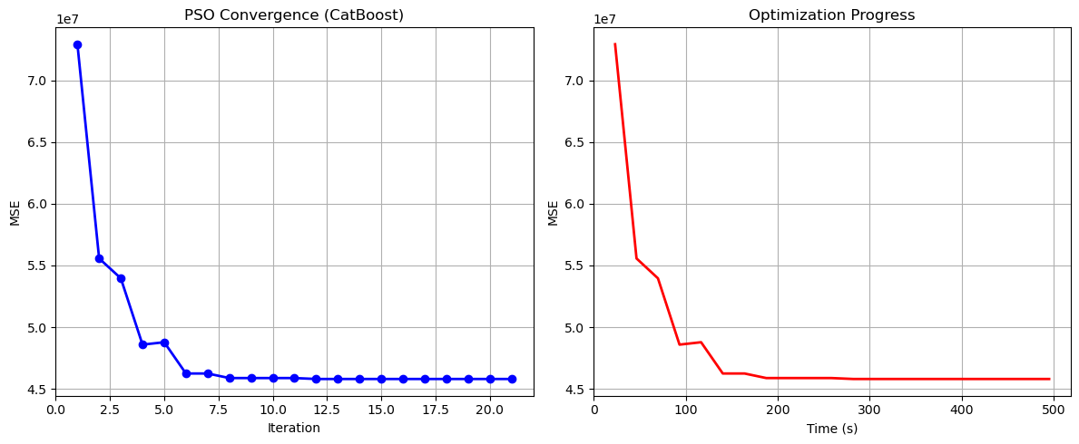

Particle Swarm Optimization completed successfully with MSE: 45799023.6283

==================================================

Running Whale Optimization...

==================================================

==================================================

=== WHALE OPTIMIZATION ALGORITHM ===

==================================================

[Initialization]

- Population: 30 whales

- Max iterations: 20

- Spiral coefficient (b): 1.0

- Search space: 16 features

- Target: Minimize MSE using CatBoost

[Optimization Progress]

Iter 20/20 | Best MSE: 45383746.958268

==================================================

=== OPTIMIZATION RESULTS ===

==================================================

▶ Best MSE achieved: 45383746.958268

▶ Time elapsed: 475.84 seconds

▶ Features selected: 16/16 (0.0% reduction)

▶ Selected features:

1. region

2. year

3. manufacturer

4. model

5. condition

6. cylinders

7. fuel

8. odometer

9. title_status

10. transmission

11. drive

12. type

13. paint_color

14. state

15. lat

16. long

▶ Convergence progress:

- Initial MSE: 71179328.3082

- Final MSE: 45383746.9583

- Improvement: 36.2%

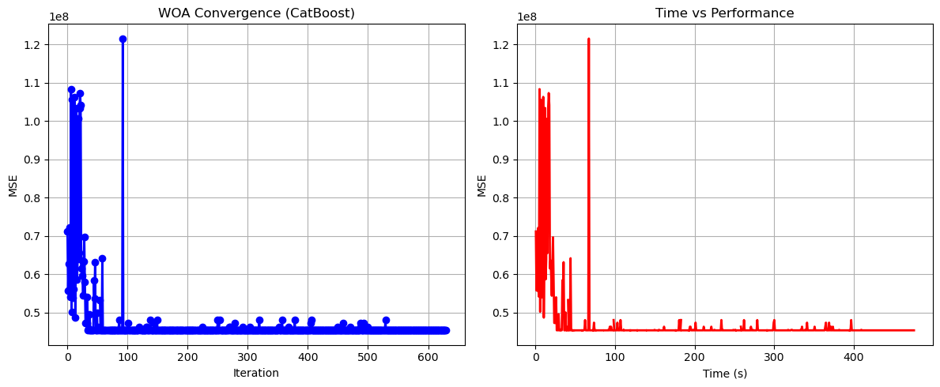

Whale Optimization completed successfully with MSE: 45383746.9583

==================================================

Running Squid Game Optimizer...

==================================================

==================================================

=== SQUID GAME OPTIMIZER (SGO) ===

==================================================

[Initialization]

- Players: 30 (15 offensive, 15 defensive)

- Max games: 20

- Search space: 16 features

- Target: Minimize MSE using CatBoost

==================================================

=== OPTIMIZATION RESULTS ===

==================================================

▶ Best MSE achieved: 45932612.280256

▶ Time elapsed: 487.52 seconds

▶ Features selected: 13/16 (18.8% reduction)

▶ Selected features:

1. region

2. year

3. manufacturer

4. model

5. condition

6. cylinders

7. fuel

8. odometer

9. title_status

10. drive

11. type

12. paint_color

13. long

▶ Convergence progress:

- Initial MSE: 46189695.3747

- Final MSE: 45932612.2803

- Improvement: 0.6%

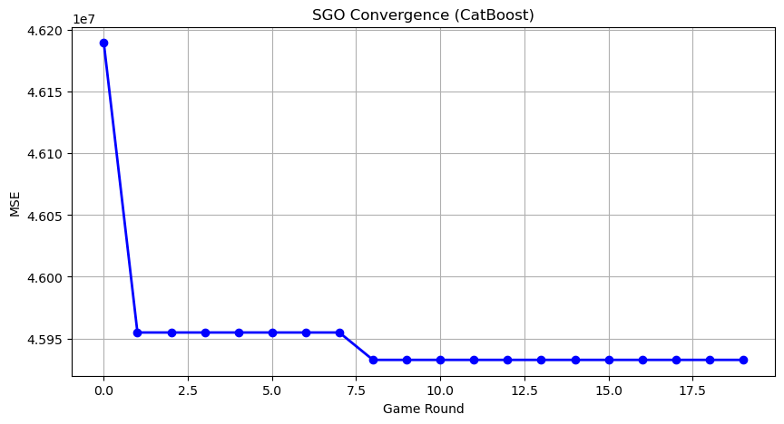

Squid Game Optimizer completed successfully with MSE: 45932612.2803

==================================================

Running PSH-Hyptrite...

==================================================

==================================================

=== PSH-HYPTRITE OPTIMIZATION ===

==================================================

[Initialization]

- Search points: 30

- Max iterations: 20

- Initial radius: 0.5 (adaptive)

- Hypersphere samples: 3 per point

- Search space: 16 features

- Target: Minimize MSE using CatBoost

[Optimization Progress]

Iter 20/20 | Best MSE: 45400499.657381 | Radius: 0.0250

==================================================

=== OPTIMIZATION RESULTS ===

==================================================

▶ Best MSE achieved: 45400499.657381

▶ Time elapsed: 1430.36 seconds

▶ Features selected: 15/16 (6.2% reduction)

▶ Selected features (with weights):

1. year (weight: 1.000)

2. manufacturer (weight: 0.885)

3. model (weight: 0.667)

4. condition (weight: 0.501)

5. cylinders (weight: 0.763)

6. fuel (weight: 0.925)

7. odometer (weight: 0.573)

8. title_status (weight: 0.515)

9. transmission (weight: 0.897)

10. drive (weight: 0.891)

11. type (weight: 0.681)

12. paint_color (weight: 0.623)

13. state (weight: 0.520)

14. lat (weight: 0.508)

15. long (weight: 0.774)

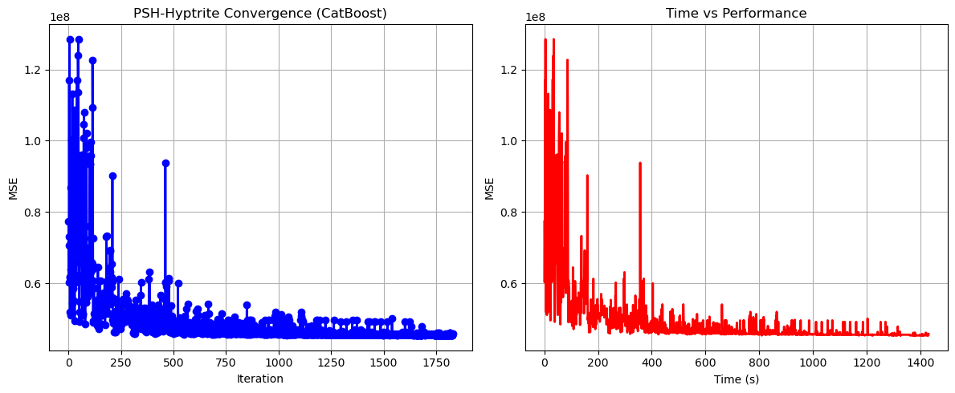

PSH-Hyptrite completed successfully with MSE: 45400499.6574

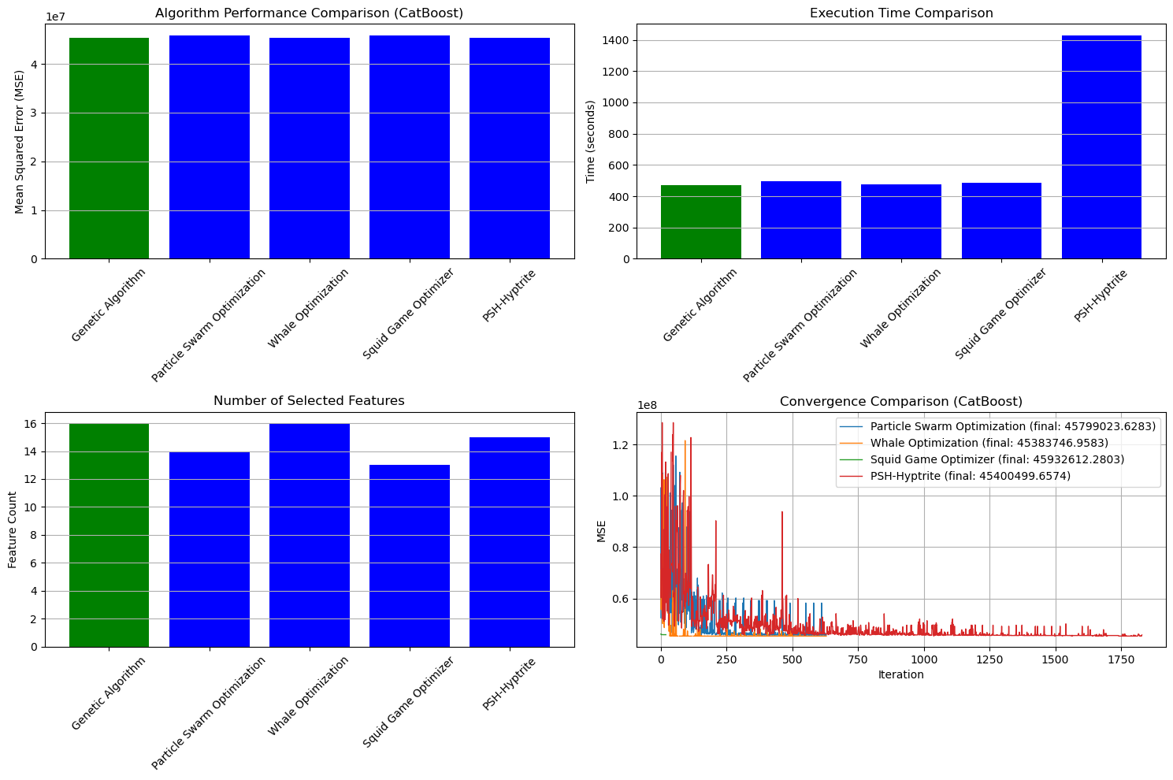

==================================================

FINAL RESULTS SUMMARY (Using CatBoost)

==================================================

🏆 Best Algorithm: Genetic Algorithm

📉 Best MSE Achieved: 45383746.958268

⏱️ Execution Time: 472.52 seconds

🔢 Features Selected: 16

Selected Features:

1. region

2. year

3. manufacturer

4. model

5. condition

6. cylinders

7. fuel

8. odometer

9. title_status

10. transmission

11. drive

12. type

13. paint_color

14. state

15. lat

16. long